Ex.no:6c | DATA VISUALIZATION USING POWER BI

Aim:
To clean, preprocess, and transform the raw Fashion Products Analysis dataset, load the cleaned data into Power BI, and build an interactive visual dashboard to analyze product pricing, ratings, brands, categories, colors, and sizes.
Algorithm:
- Import Dataset: Load fashion_products.csv into the environment.
- Deduplication: Identify and delete duplicate rows across all fields.
- Remove Blank Rows: Identify and remove completely blank records from the dataset.
- Handle Missing Values: Identify missing values in each column and replace or remove them appropriately to maintain data consistency.
- Handle Data Type Errors: Convert numerical attributes such as Price and Rating into appropriate numerical data types.
- Clean Text Data: Remove unnecessary spaces and standardize categorical values such as Product_Name, Brand, Category, Color, and Size.
- Create Product Analysis: Calculate required product metrics such as average price and average rating for analysis.
- Load Clean Data: Load the cleaned Fashion Products dataset into Power BI Desktop using Get Data → Text/CSV and select Transform Data if further cleaning is required.
- Create Core Metrics: Create measures in Power BI to calculate the total number of products and average price.
Output:
1.BAR CHART
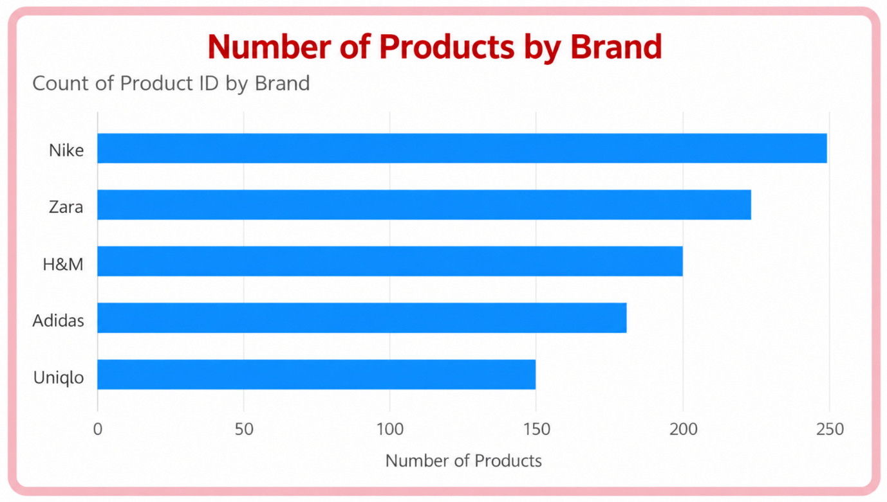

2.Column Chart
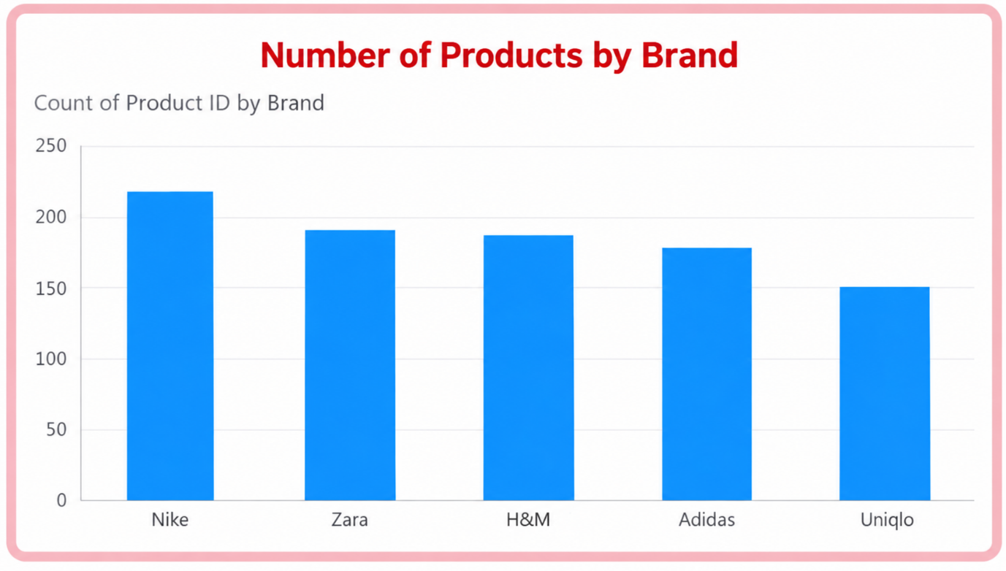

3.Donut Chart
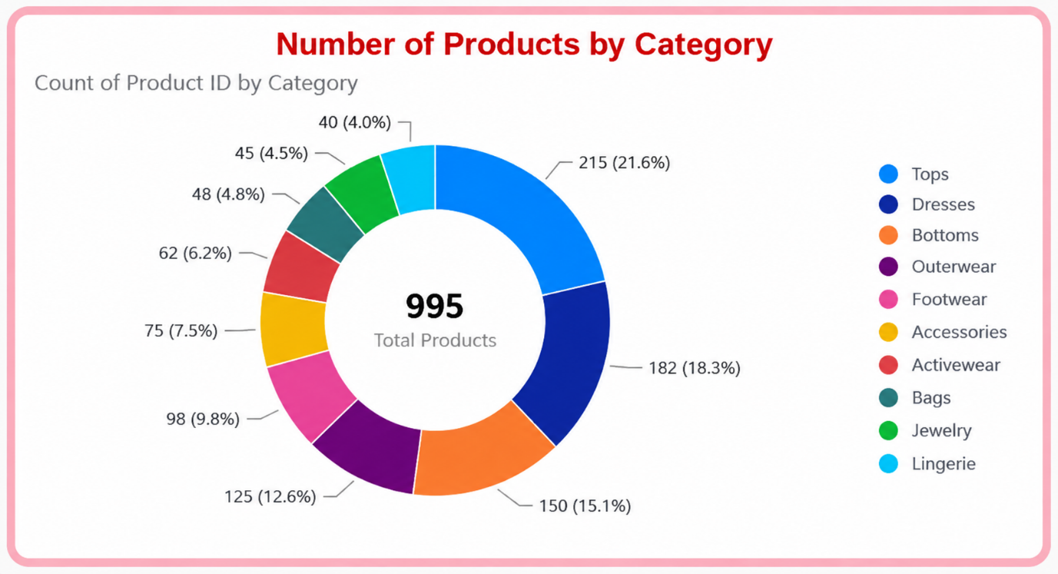

4.KPI CARD
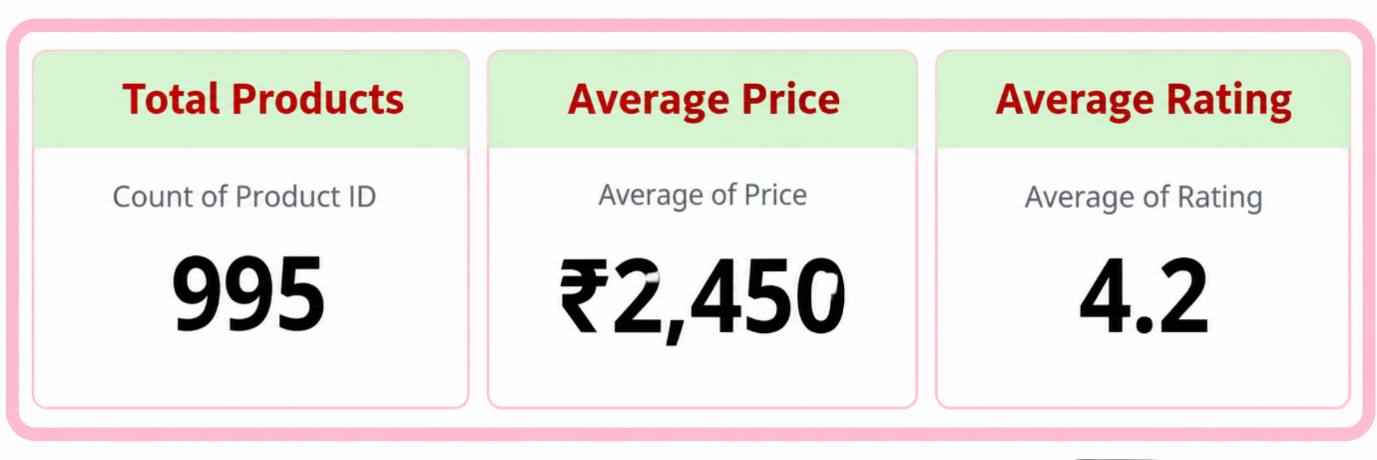

5.Line Chart

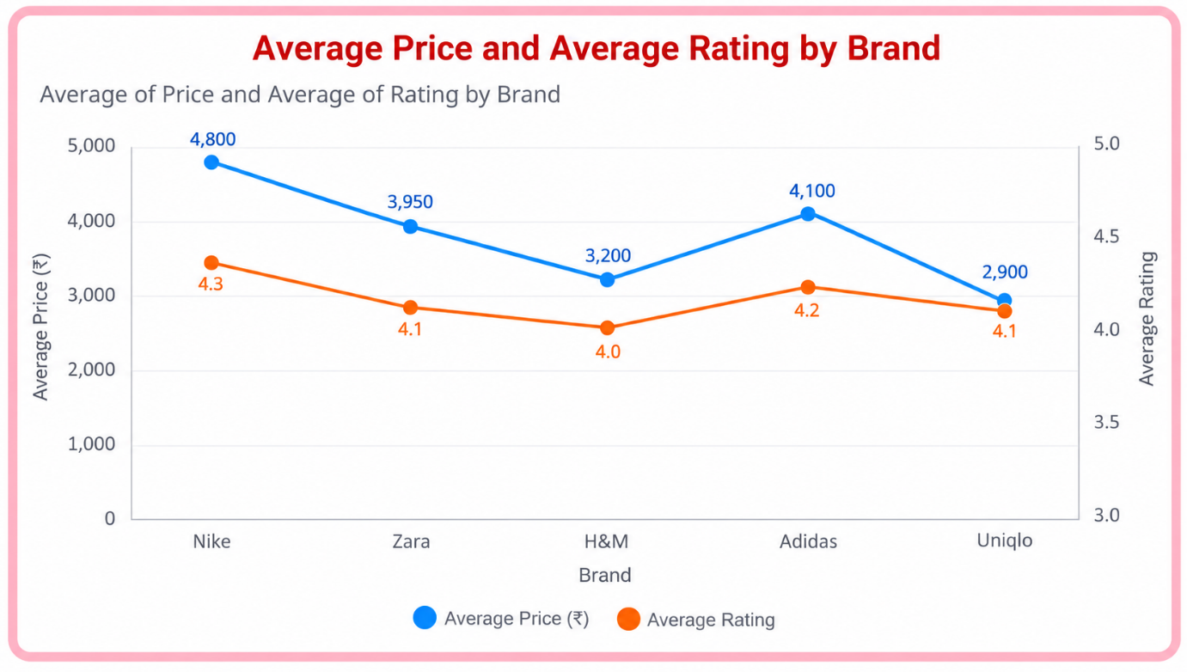

6.Clustered Column Chart
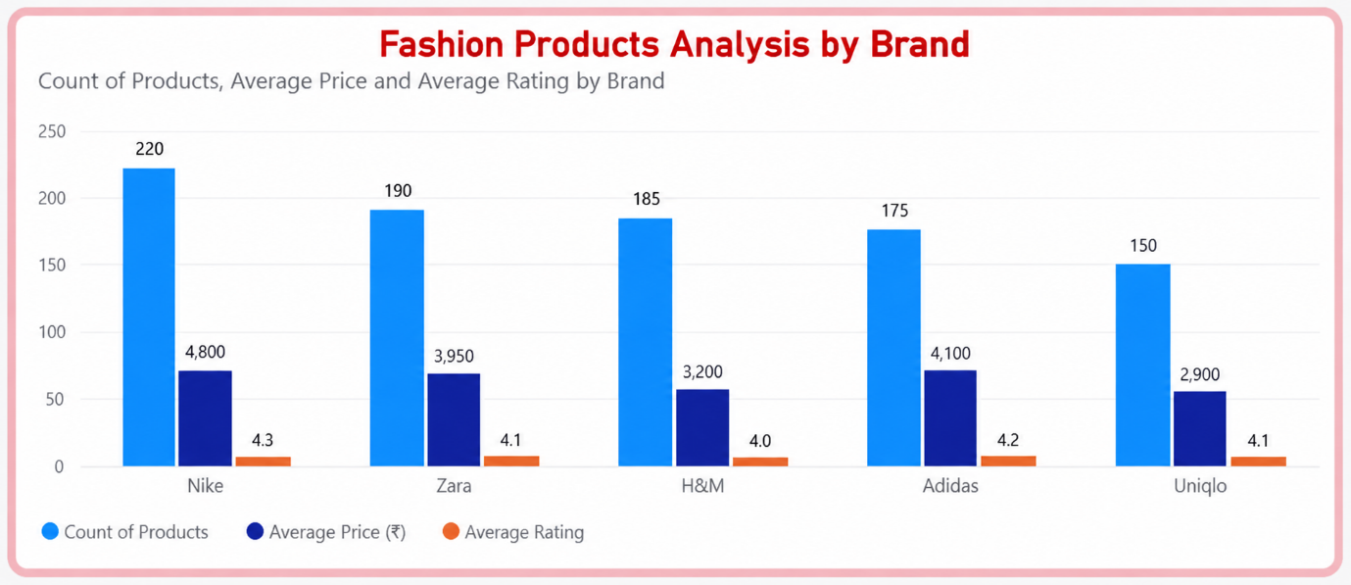

7.DASHBOARD

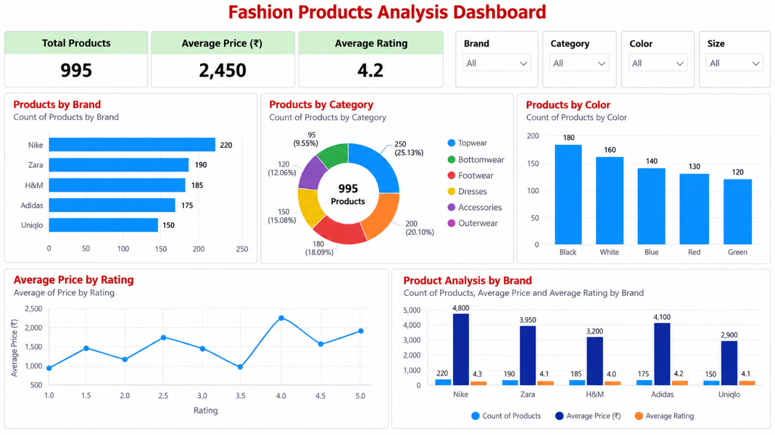

Result:

